DATA STRUCTURE AND ALGORITHM
Name: Lorenzo M. Bautista Prof: Ma’am Gloria Dela Cruz
Section: BSIT 104 Date: March 25, 2026

LABORATORY 4
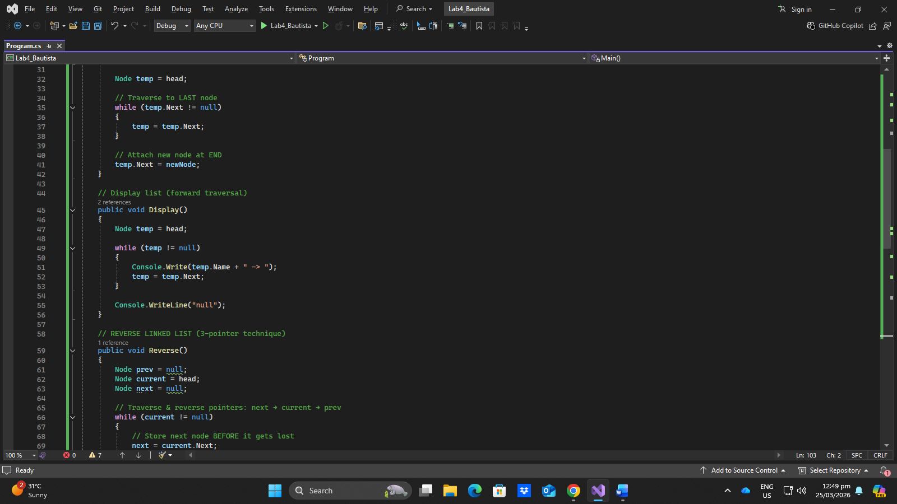
Code:
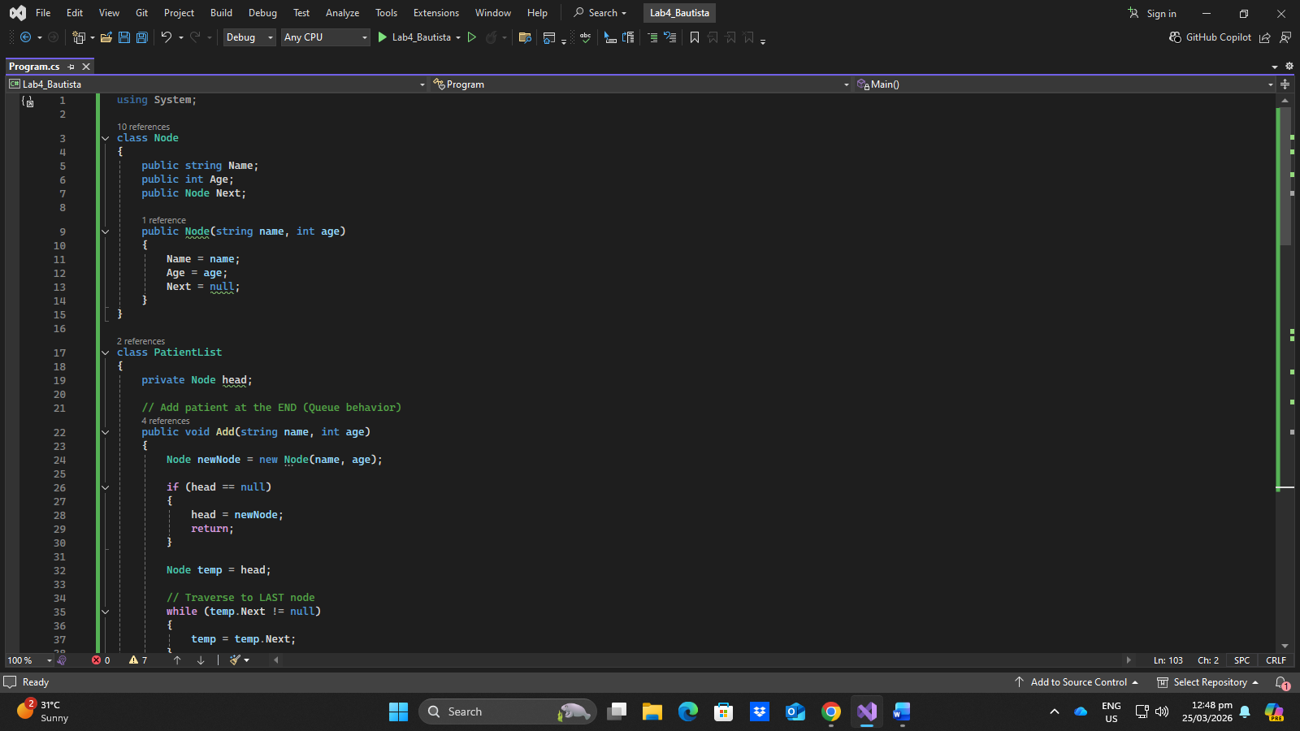

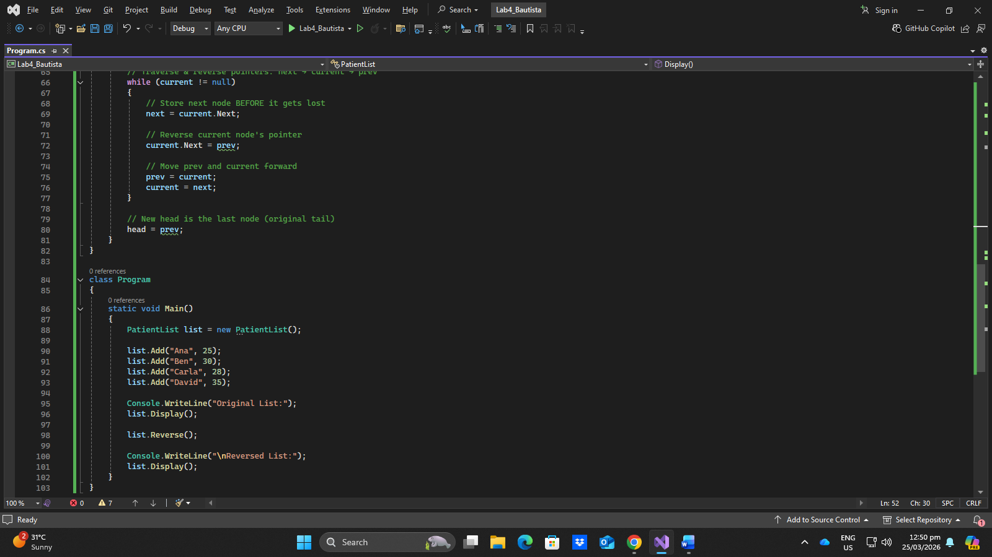

Output:
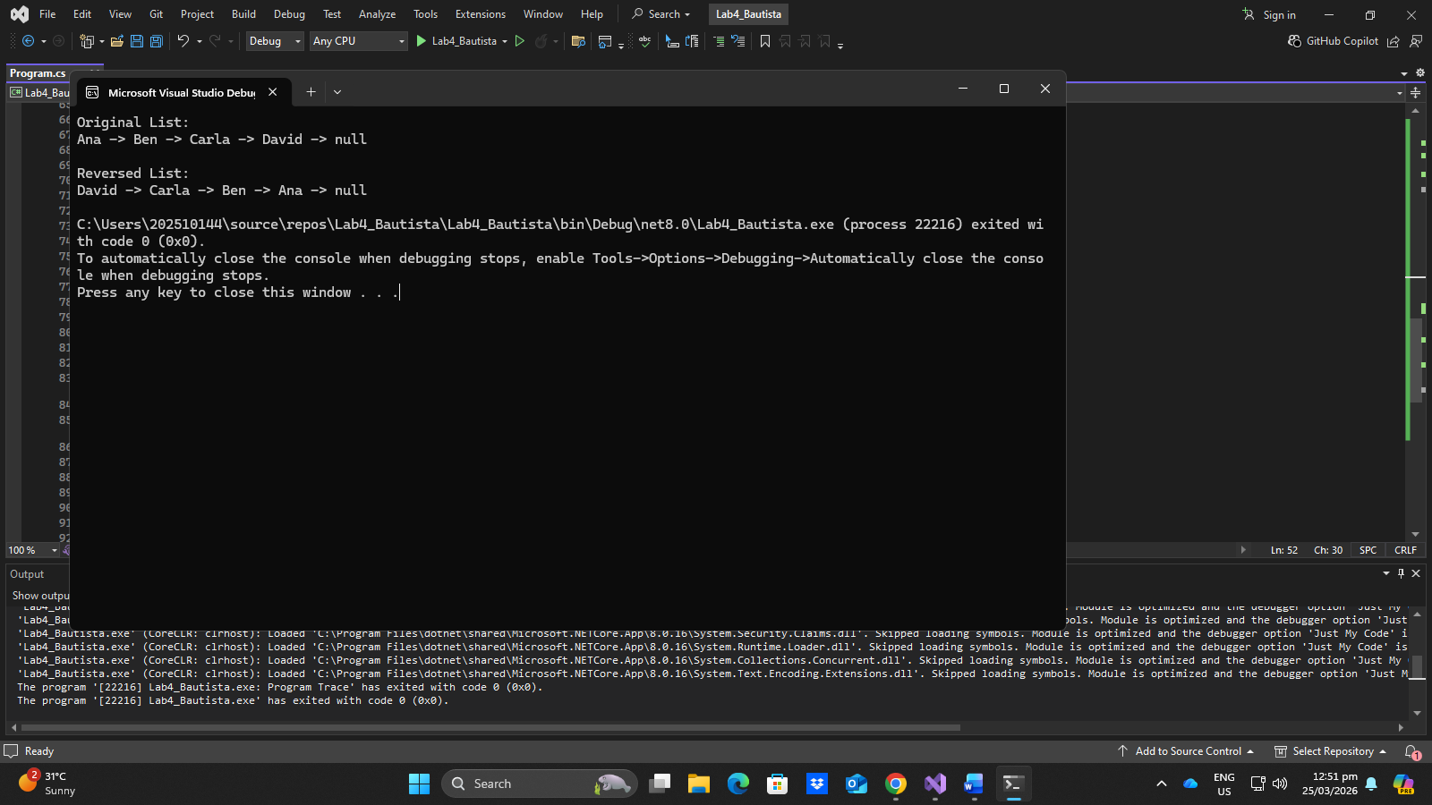
Questions:
- Why do we need three pointers in reversing?
Without three pointers in reversing the links breaks and the data will be lost.
- What happens if you don’t store next?
If we don’t store next data will be lost, because next is the lifeline that prevents data loss.
- What is the time complexity of reversing?
The time complexity of reversing because the algorithm makes a single pass through the entire list.
- Can you reverse it using recursion?
Yes, you can reverse using recursion but it uses an extra space due to the recursion in the stack and risks stack overflow for large lists.
- What happens if the list is empty?
If the list is empty nothing will happen since it remains null.

